CERTIFICATE OF CONFORMITY TO OEM REFERENCE

Juratek Product Reference | DAF111C
Product Description | Brake Disc
OE Part Number | 1387439,1640561,1726138,1812582
Application(s): | DAF CF65, CF75, CF85, LF55, XF95,XF105
Application(s): | DAF Bus SB4000
Supplier Quality Approval | BS EN ISO9001: 2008

We certify that the goods detailed above conform to the material & dimensional specifications required by Juratek Ltd and that they are fit for direct OEM replacement.

Print Name: | Andrew Kibler
Signed: | 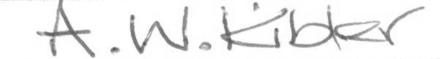
Position: | Quality & Engineering Manager
Date: | 30 July 2026

